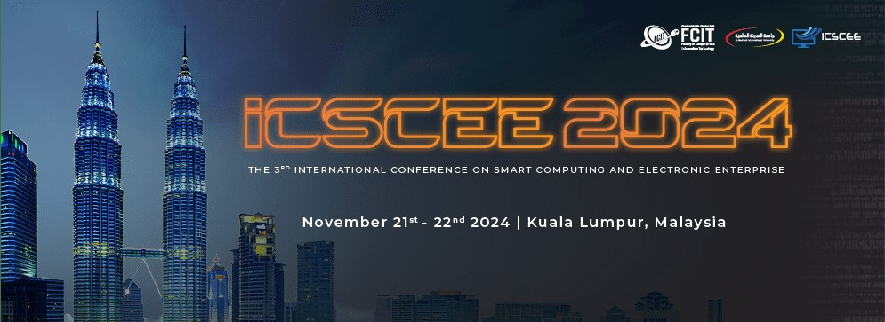
Participation Form
The 3rd International Conference on Smart Computing and Electronic Enterprise (ICSCEE 2024)
Personal Information
Name
Nationality
Academic title
Occupation/ Profession
Employer/ Workplace
Address
Phone number/ WhatsApp number:( is very necessary; To facilitate the communication process)
E-mail
Please ()
Type of Participants and The Payment
Participants with a paper from inside and outside Malaysia - physical attendance (200 USD)
Participants with a paper from inside and outside Malaysia – online attendance (150 USD)
Professors / Students participating with papers (without publication fee) from Al-Madinah International University
(50 USD)
Professors / Students participating without papers from Al-Madinah International University (10 USD )
Research Title
Research Area
Note: Please send this form, along with your personal photo and CV, to the following email:
icscee@mediu.edu.my

